Birds’ Eggs 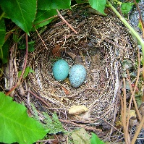
Equipment: You will need 19 counters or objects
Puzzle;
3 birds laid some eggs.
Each bird laid an odd number of eggs.
Altogether they laid 19 eggs.
Question;
How many eggs did each bird lay?
How many different ways can you find to do it?
